**Circuit Diagram & Truth Table:**

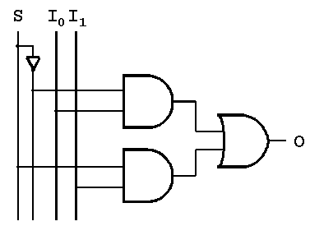

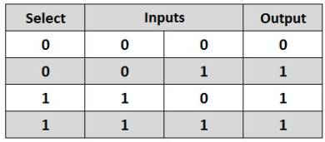

**Code:**

* **Design Module**

module mux(out,s0,i0,i1);

input s0,i0,i1;

output out;

wire s0n,a,b;

not n1(s0n,s0);

and a1(a,s0n,i0);

and a2(b,s0,i1);

or o1(out,a,b);

endmodule

* **TestBench**

module Baig;

reg s0,i0,i1;

wire out;

mux m1(out,s0,i0,i1);

initial

begin

s0=1'b0;i0=1'b0;i1=1'b0;

#20

s0=1'b1;i0=1'b0;i1=1'b1;

#20

s0=1'b0;i0=1'b1;i1=1'b0;

#20

s0=1'b1;i0=1'b1;i1=1'b1;

#20

$finish;

end

endmodule

**Output:**

